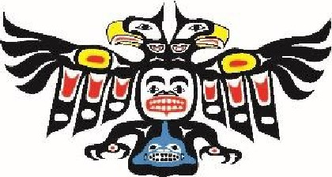

shishalh
NATION

FOR IMMEDIATE RELEASE
June 21, 2023

shíshálh placenames returned within the swiya.

shíshálh swiya - Effective June 21, 2023, ten placenames within the shíshálh swiya (lands, world, birthplace, “Territory”) have been restored as part of the cooperative work under the shíshálh-B.C. Foundation Agreement.

shíshálh Nation and the Province have restored the names of the following water features: Jervis Inlet to lekw’emin, Earls Cove to skelh, Pender Harbour to kalpilin, Deserted Bay to ts’unay, Deserted River to ts’unay stulu, and Hunaechin Creek to xenichen stulu. In addition to the water features above, Mount Victoria has been returned to k’els. Further, the following previously unnamed features, have been officially named: the major village site at the head of lekw’emin has been named xenichen, the major village site at the mouth of ts’unay stulu has been named ts’unay, and the previously unnamed lake east of Chapman Lake within the Tetrahedron Park has been named mala/Hind-Smith Lake.

“This is a great achievement that shows the importance of our journey together towards reconciliation. These placenames have great meaning to the shishalh people that dates to time immemorial,” said lhe hiwus Yalxwemult (Chief Lenora Joe), shíshálh Nation. “Recognizing these original placenames honours our ancestors, heals and teaches our present shishalh members and will continue to revitalize our language and culture for future generations. We are grateful for the support of our provincial and regional district partners. There is no end date to reconciliation. We continue to learn and work together to bring real progress to reconciliation.”

“The restoration of these 10 placenames back to their Indigenous origins is an important part of the work our government is doing in partnership with the shíshálh Nation to advance meaningful reconciliation in this province,” said Lana Popham, Minister of Tourism, Arts, Culture and Sport. “Indigenous names hold great significance. Recognizing the cultural history and heritage values of these places fosters greater understanding and appreciation among both residents and visitors for their deep history.”

The 2018 Foundation Agreement between the shíshálh Nation and the provincial government includes consideration of several changes back to shíshálh placenames. The agreement also includes transfer of land to shíshálh and commitments for co-operation on land-use planning and shared decision-making.

Recognizing and restoring these important placenames is an important step on the path of reconciliation and part of the implementation of the United Nations Declaration on the Rights of Indigenous Peoples through the Declaration on the Rights of Indigenous Peoples Act.

In accordance with the B.C. Geographical Naming Policy, local and indigenous governments, as well as relevant organizations, were invited to comment on the proposed name changes and bring forward any local heritage considerations and comments. The comment period was from September 2022 to April 2023. Input during the comment period showed broad support for the restoration of these names.

Contact:
lhe hiwus Lenora Joe
604.885.2273

