INFORMATION BOOK FOR THE Shíshálh Nation Referendum
regarding the

SSC PROPERTY PURCHASE

REFERENDUM DATE: MAY 2, 2020

ADVANCE POLL: April 26, 2020

What is the Purpose of this Information Book?
The purpose of this Information Book is to provide shíshálh Nation members with information about the Referendum that is being held on May 2, 2020 (with the advance poll to take place on April 26, 2020) in relation to the question of whether shíshálh Nation should purchase the SSC Property from Tsain-Ko Run of River Access GP.

In the referendum, shíshálh Voters will be asked to answer “Yes” or “No” to the following question:
Do you approve of shíshálh Nation purchasing the SSC property, as described in the information package, from Tsain-Ko Run of River Access GP?

Why are we Having a Referendum?
shíshálh Nation has the opportunity to acquire a 396.859 acre (160.60 hectare) site consisting of 10 legal parcels, including approximately 1,500 linear feet of waterfront (the “SSC Property”), from Tsain-Ko Run of River Access GP (“Tsain-Ko”), one of shíshálh Nation’s businesses. The SSC Property is located in Porpoise Bay on Sechelt Inlet Road and makes up one of the largest intact parcels left in Sechelt.

Tsain-Ko purchased the SSC Property in a court-ordered sale in bankruptcy proceedings on January 23, 2020 for $15,000,000. The sale of the property closed on February 24, 2020. There were several other bids for the SSC property, with the next highest bid being $14,688,000.

Because the sale of the SSC Property was court-ordered, there were significant time constraints on its purchase. Chief and Council were made aware of the court-ordered sale process for the SSC Property in late December, 2019 and undertook due diligence in relation to the property.

Given the time constraints, it was not possible for shíshálh Nation to hold a referendum prior to January 23, 2020 in order to get community approval for shíshálh Nation to purchase the SSC Property.

In early January, an information package was forwarded to shíshálh Nation members, regarding the potential purchase of the SSC Property. Two informational brunches were held at the Hall and one information meeting was held with members in Vancouver. Additionally, youth and Elders’ meetings were held.
Some councillors personally reached out to dozens of Nation members, going door to door to solicit views on the purchase. A dot-mocracy was held at one of the brunches which indicated that a majority of shíshálh Nation members in attendance were in favour of the land purchase. Polls were taken at the Elders’ and Nation member Vancouver meeting with very high support for the purchase. Further, as requested by members at the brunch, a survey-monkey questionnaire attracted 90 participants and 66 of them (77 per cent) indicated they were in favour of the land acquisition.

shíshálh Nation now has the opportunity to purchase the SSC Property from Tsain-Ko so that it can be used for shíshálh housing and economic development purposes. The purchase price is $16,218,542, which covers the purchase price plus additional costs.

Location of the SSC Property
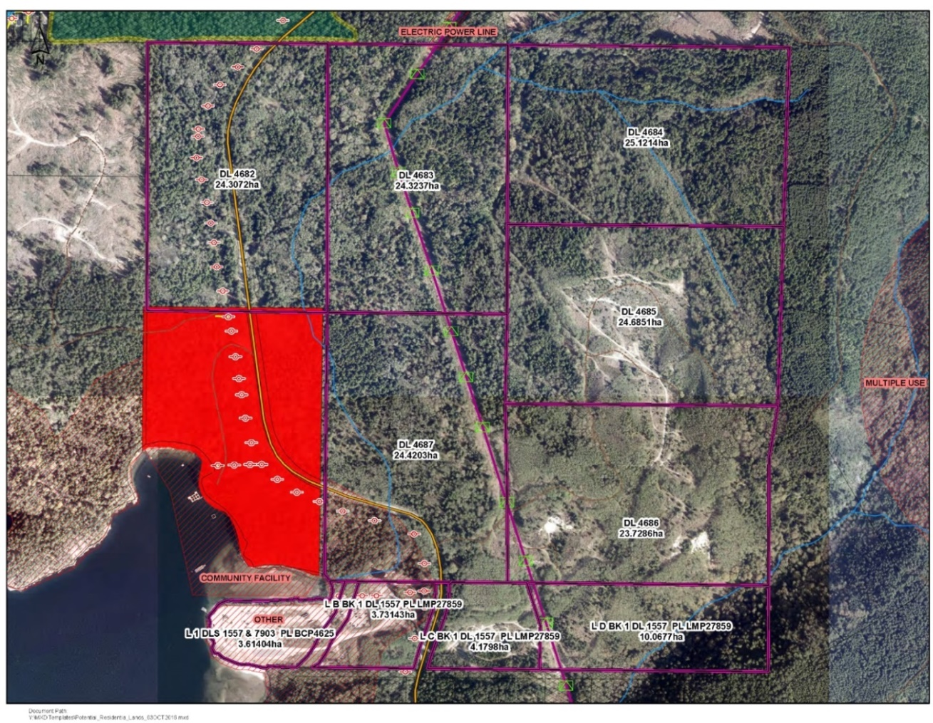

Why Purchase the SSC Property?
To assist in determining the priorities of shíshálh Nation, Chief and Council held 6 community meetings between May and September, 2019. The overall results of those meetings indicated that housing/infrastructure and economic development remain top priorities of shíshálh Nation members.

Purchasing the SSC Property will provide shíshálh Nation with the opportunity to address, in part, the priorities of the community by acquiring a large property with significant housing and economic development potential.

How will shíshálh Nation pay for the SSC Property
if Members Approve the Purchase?
There is the potential for shíshálh Nation to use funding under the Foundation Agreement that was signed with British Columbia on October 4, 2018 toward the purchase of the SSC Property. The Foundation Agreement provides that British Columbia will seek approval to provide funding for the purchase of 80 hectares of private land to be used for residential purposes, if 80 hectares of Crown land cannot be found by April 4, 2020. To date, shíshálh Nation and British Columbia have not been able to locate 80 hectares of Crown land that is zoned and suitable for residential development.

As a result, shíshálh Nation supports British Columbia seeking the necessary approvals to provide shíshálh Nation with a benefit package worth approximately 50% of the cost to purchase the SSC Property from Tsain-Ko. While there is no guarantee this request will be approved, we have support from the British Columbia negotiating team to make a strong case, given the importance of the SSC Property to meet the housing needs of the shíshálh Nation.

If British Columbia provides 50% of the purchase price, shíshálh Nation will have to make up the balance of the purchase price itself. If British Columbia does not provide the funds, shíshálh Nation will have to cover the full price of the SSC Property. shíshálh Nation would be able to cover the costs of the purchase without creating any financial stress for the Nation, or taking away funding for programs and services.

Since the SSC Property has some economic value, shíshálh Nation may be able to recoup some of the purchase price through commercial or residential developments or forestry activities. shíshálh Nation should also be able to secure a bank loan for at least part of the purchase price.

What is the plan for the SSC Property?
Under the East Porpoise Bay Neighbourhood Plan, the SSC Property is currently zoned CD-13 (Comprehensive Development Zone 13 – Silverback), allowing for approximately 1,600 residential units, 32,000 square feet of commercial space, a six story 120 room hotel, and an 18 hole golf course. Some of the possible future uses of the SSC Property include:
- Housing development for shíshálh Nation members.
- Some forestry resources remain on the SSC Property and it may be possible to extract them.
- Reactivating the fish hatchery on the McLean Bay property.
- Economic development opportunities including the development of a hotel, apartment complexes and tourism-related infrastructure.
- Industrial and recreational opportunities on the waterfront.
- Potential for subdivision.

Potential Benefits
- Strategic opportunity for shíshálh Nation to hold one of the largest intact parcels in Sechelt.
- Potential new housing development for shíshálh Nation and very few other lands available for housing.
- Opportunity to expand shíshálh Nation Lands (Sechelt Band Lands).
- Parcel borders SNL/SBL 28.
- shíshálh Nation can negotiate with the District of Sechelt for sewage expansion and removal of existing covenants, if desired.
- 1,500 linear feet of waterfront.
- Three water licences are associated with the SSC property.
- Location is approximately 4 km from Sechelt and close to amenities.
- Hydro is in close proximity.
- Long term asset of the shíshálh Nation, which can be sold to recover funds if necessary.
- Low purchase price as prices of acre lots on the coast are very high – per acre cost for this parcel is $37,792.89.
- Economic development opportunities including:
  - Some forestry resources remain on the SSC Property and it may be possible to extract them.
  - Economic development and partnership opportunities including the development of a hotel, apartment complexes and tourism-related infrastructure.
  - Industrial and recreational opportunities on waterfront.
  - Potential for subdivision.
  - Re-activation of the hatchery at McLean Bay.
  - Partnership potential (e.g. hotel).
  - Potential for tourism opportunities including water-based activities and a zip line.
  - International school.

Potential Challenges
- Existing Covenant that requires investment in District of Sechelt infrastructure and low income housing, limits the number of housing units that can be built, requires construction of a golf course and hotel, and requires commercial space to be built.
- There is no current agreement with District of Sechelt to hook up to local sewage systems. shíshálh Nation may need to build a sewage facility which will be an added cost.
- Road improvements will be required for ti’ta Way and other existing infrastructure to handle increased traffic.
- There will be added expenses to prepare the SSC Property for suitable building.
- Environmental considerations:
  - Previously used as gravel mine.
  - Sensitive eelgrass and shellfish habitats along the foreshore will require careful development.

What if Members vote against the purchase of the SSC Property?
If members vote “No” to shíshálh Nation purchasing the SSC Property from Tsain-Ko, Tsain-Ko will continue to hold the lands for economic development purposes. However, the SSC Property would not be used for housing purposes in that case, and the SSC Property could not become shíshálh Nation Lands.

SSC Property Frequently asked questions
Question | Answer
What is the water supply on the SSC Property? | 3 water licences for wells which could supply a large number of homes.
Can the water be used to re-start the hatchery? | Yes.
How will we protect cultural practices such as hunting? | Chief and Council will develop the property giving due consideration to impacts on, and opportunities for, cultural practices.
What development challenges are there, if any? | shíshálh Nation will need to negotiate the removal of the current restriction on the SSC Property relating to development, and access to sewage, with District of Sechelt. shíshálh is confident our government-to-government relationship will allow for a successful negotiation.
Did Chief and Council consider building on SNL 5? | Yes, but SNL 5 has limited infrastructure and can only service 10 homes.
What would the costs of development of the SSC Property be? | If the SSC Property is purchased by shíshálh Nation, a full business plan will be developed to determine development potential and costs.
What property taxes are associated with the SSC Property? | $61,000 annually.

Referendum Process
Key Referendum events and their associated dates are set out below. For further details, it is recommended that the shíshálh Nation Election and Referendum Law and the shíshálh Nation Constitution be referred to. Copies of both can be obtained at shíshálh Nation’s main administration building and on the shíshálh Nation’s website.

Eligibility to Vote in the Referendum

All individuals on the shíshálh Nation’s Membership List who will be at least 18 years of age on May 2, 2020 are eligible to vote in the Referendum. However, only those individuals who are listed on the final Voters’ List will be entitled to vote in the Referendum.

Electoral Officer

On January 28, 2020, Chief and Council appointed Wendy Lee as the Electoral Officer to conduct the Referendum. Wendy can be contacted by email or phone as follows:

Email: wendylee@secheltnation.net Cell: 604.669.7887
Voters’ List

The Electoral Officer will post a draft Voters’ List on or before March 3, 2020 in a public area of shíshálh Nation’s main administration building, and publish it electronically. If your name does not appear, or is incorrect, on the Voters’ List, you may send an application in writing to the Electoral Officer by April 2, 2020 to ask to have your named added to, or changed on, the Voters’ List.

If someone’s name appears on the Voters’ List who you think should not be on the Voters’ List you may send an application in writing to the Electoral Officer by March 23, 2020 to ask for that person’s name to be removed from the Voters’ List.

The Electoral Officer will make the final decision on who is entitled to be on the Voters’ List and will post the final Voters’ List on or before April 22, 2020 in a public area of shíshálh Nation’s main administration building, and publish it electronically.

Voting by Mail-In Ballot

Every Voter who does not reside on Sechelt Lands is entitled to vote by mail-in ballot if they send the Electoral Officer a completed Application for Remote Ballot by April 2, 2020.

Voters who live on Sechelt Lands but who can’t vote in person due to a disability may also vote by mail-in ballot if they send a completed Application for Remote Ballot to the Electoral Officer by April 2, 2020.

Location of Polling Stations on the Date of the Advance Poll

An Advance Poll will be taking place on April 26, 2020. The Polling Station will be located in the Elder’s Boardroom and will be open from 2:00 p.m. until 6:00 p.m.

Location of Polling Stations on the Date of the Referendum

The Referendum will be taking place on May 2, 2020. The Polling Stations will be located in the Elder’s Boardroom and will be open from 9:00 a.m. until 8:00 p.m.

Referendum Outcome

If majority of Voters vote “yes” to the question, shíshálh Nation will proceed to purchase the SSC Property from Tsain-Ko.

If a majority of Voters vote “no” to the question, shíshálh Nation will not purchase the SSC Property from Tsain-Ko.

If the difference between “yes” and “no” votes is 5 votes or less, including a tie, the Electoral Officer will immediately conduct a recount of the votes. If, after a recount, a tie remains, the question will not pass and shíshálh Nation will not purchase the SSC Property from Tsain-Ko.

Appeals of Referendum Results

Voters can appeal the results of the Referendum by June 1, 2020. Appeals are filed by delivering a notice of appeal to the Electoral Officer.

Appeals can only be successful if one or more of the following occurred:
- there was a violation of a provision of the Constitution or the Election and Referendum Law in the conduct of the Referendum that might have affected the result of the Referendum; or
- there was a Corrupt or Fraudulent Practice in relation to the Referendum, meaning that in relation to the Referendum, there was the giving or taking of a bribe, intimidating of a Voter, Referendum official, or other conduct that is defined as a corrupt or fraudulent practice under a shíshálh Nation Law.

Referendum Key Dates and Events
Initial Voters’ List posted | March 3, 2020, at the latest
Notice of Referendum posted/circulated | March 3, 2020, at the latest
Deadline to appeal the inclusion of a person’s name on the Voters’ List | March 23, 2020
Deadline to apply to be added to, or to change your name on, the Voters’ List | April 2, 2020
Deadline to request a mail-in ballot | April 2, 2020
Notice of Polls posted | April 2, 2020, at the latest
Final Voters’ List posted | April 22, 2020, at the latest
Advance Poll | April 26, 2020
Deadline for delivery of mail-in ballots to the Electoral Officer | May 2, 2020 prior to close of polls
Referendum | May 2, 2020
Deadline to appeal Referendum results | June 1, 2020

Questions?
If you have any questions about the SSC Property, please contact Christ August by email or phone as follows:

Email: caugust@secheltnation.net Cell: 604.740.5600

If you have any questions about the Referendum process generally, please contact the Electoral Officer, Wendy Lee, by email or phone as follows:

Email: wendylee@secheltnation.net Cell: 604.669.7887

