Notice of Election by Acclamation

The following shíshálh Nation Members are hereby declared elected by acclamation as Councilors effective February 15, 2020.

- August, Corey
- August, Selina
- Joe, Barbara
- Paul, Alvina

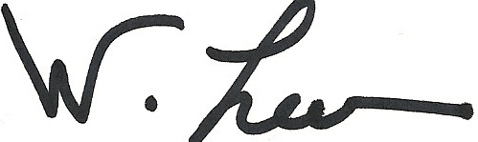
_____________________________________
Wendy Lee, Electoral Officer
shíshálh Nation
wendylee@sechelt.net
cel 604.669.7887

Date: January 8, 2020

