Notice of Election

Pursuant to Section 11 of the shíshálh Nation Election and Referendum Law notice is hereby given for the election of Chief and Councilors for the shíshálh Nation.

- A copy of the Constitution and Election and Referendum Law can be obtained at the Administration Building and electronically www.secheltnation.ca

- The Voters list is posted in all administration buildings of the shíshálh Nation offices and available electronically from the Electoral Officer: wendylee@secheltnation.net

- Voters who are ordinarily resident on shíshálh Nation and unable to vote in person due to disability may vote by mail-in ballot

- Voters who are not ordinarily resident on shíshálh Nation lands are entitled to vote by mail-in ballot

- The Electoral Officer’s contact information: Wendy Lee, 5545 Sunshine Coast Highway, Box 740, Sechelt, BC, V0N 1V0; 604.669.7887 wendylee@secheltnation.net

- The Arbitrator’s contact information: David Magnuson-Ford, 1611 Grady Road, Gibsons, BC, V0N 1V6; 604.354.6273 dmfdreammanagement@gmail.com

- The election will be held on February 15, 2020

- The Advance Poll will be held on February 9, 2020

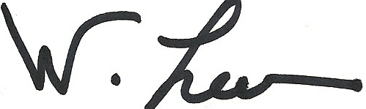
__________________________ Dated: December 10, 2019

Wendy Lee, Electoral Officer

